AIEBOOKGENERATOR.AI EDITION
Milo and the Moonlit Map
A small adventure about finding the next light
By AI Ebook Generator Studio

Copyright
Copyright 2026 by AI Ebook Generator Studio
All rights reserved.
Published by Content Petit LLC
No part of this publication may be reproduced or distributed without permission, except as allowed by law.

Dedication
For small travelers and the lights that wait for them.

Acknowledgments
This book was produced internally by the AI Ebook Generator team as a product demonstration. It is not a customer book, testimonial, sales claim, or publishing result.

Scene 1

A map beneath the oak
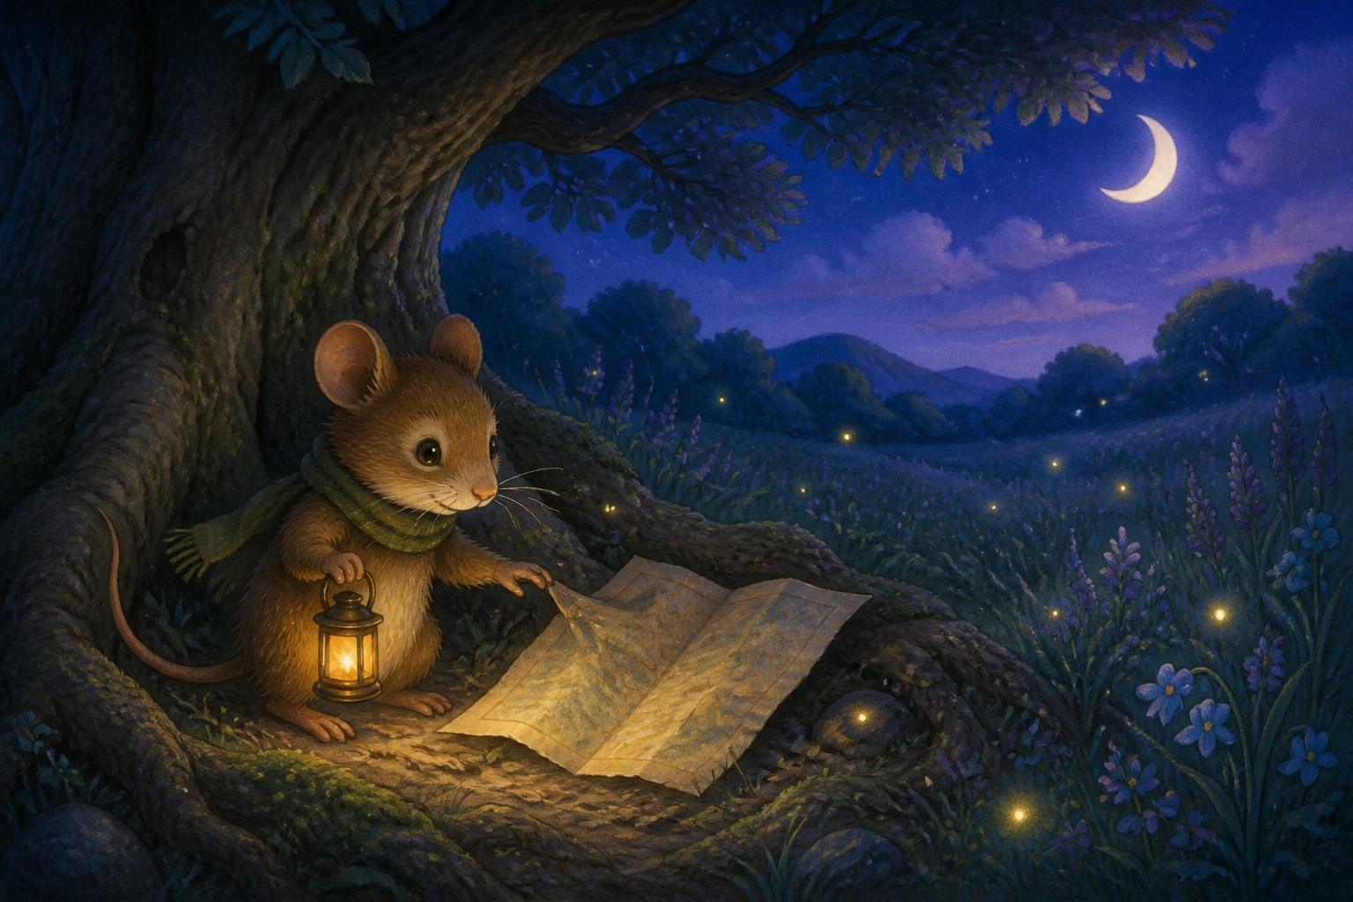
Milo liked paths he already knew. The path to the berry patch bent around three stones. The path to the creek passed the log with silver moss. And the path home always ended at a round blue door.
One evening, while fireflies blinked beneath the old oak, Milo found a folded map between the roots.
It had no words. A pale line curved across the paper and ended in a tiny golden circle.
Milo lifted his brass lantern. "Just to the creek," he whispered.
He wrapped his green scarf twice, tucked the map beneath one paw, and stepped beyond the path he knew.
Scene 2

The silver creek
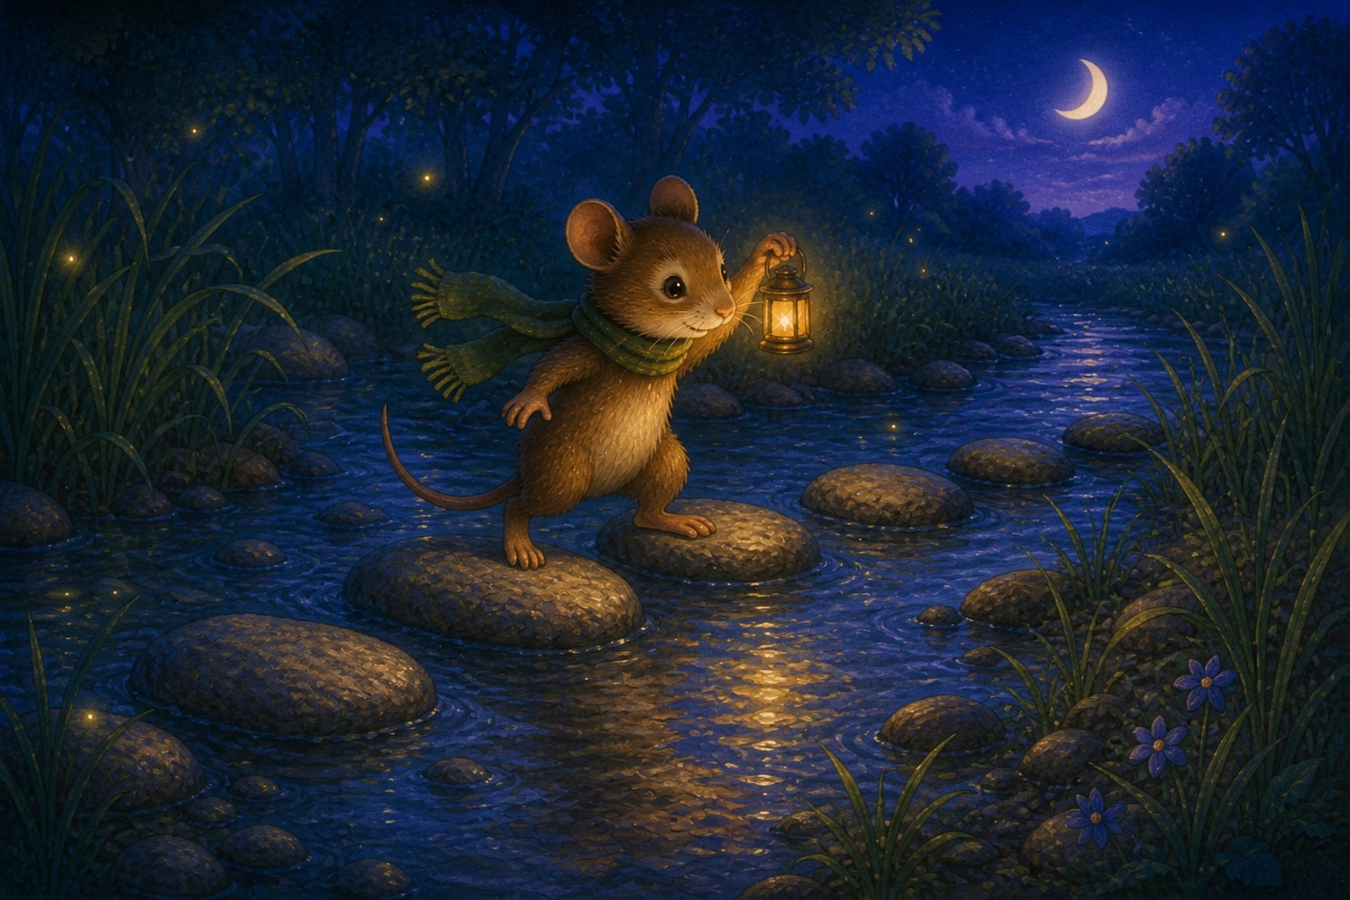
The map's pale line led to the creek, where moonlight skipped from stone to stone.
Milo's first step was easy. His second made a small splash. On the third stone, the water curled around his toes and his lantern swung in a bright little circle.
"One stone, then the next," Milo said.
He did not look all the way to the far bank. He looked for the next dry place to put his paw.
Stone by stone, the reeds moved behind him. When Milo reached the other side, the golden circle on the map seemed a little warmer.
Scene 3

When the lantern went dark
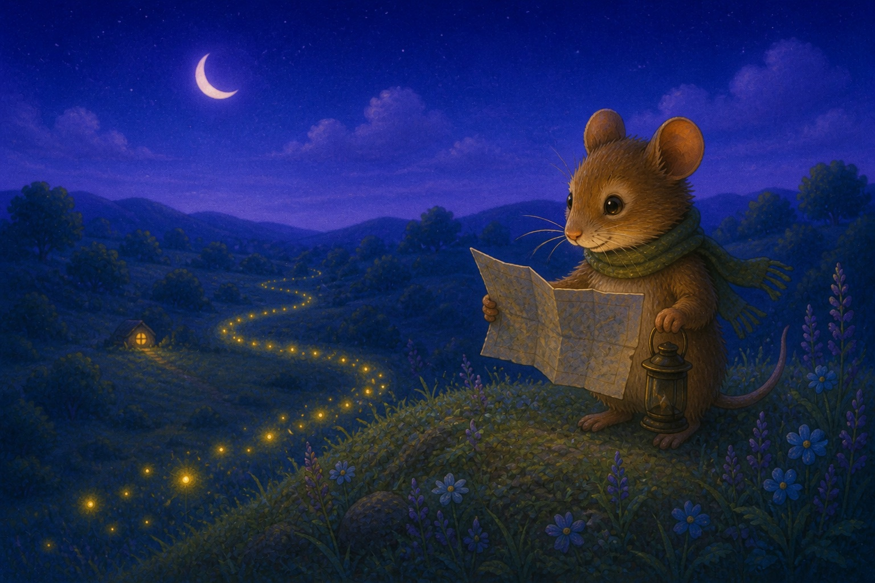
At the top of the round hill, a soft wind rushed past Milo's whiskers.
Puff.
His lantern went dark.
For a moment, every path disappeared into blue grass. Milo held the map close, but its pale line had faded too.
Then one firefly glowed near his paw. Another blinked farther down the hill. A third shone beside a familiar patch of purple flowers.
The lights did not make the whole journey bright. They made one small curve he could follow.
Far below, a round window answered with a warm golden dot.
"Home," Milo breathed.
Scene 4

The light in the window
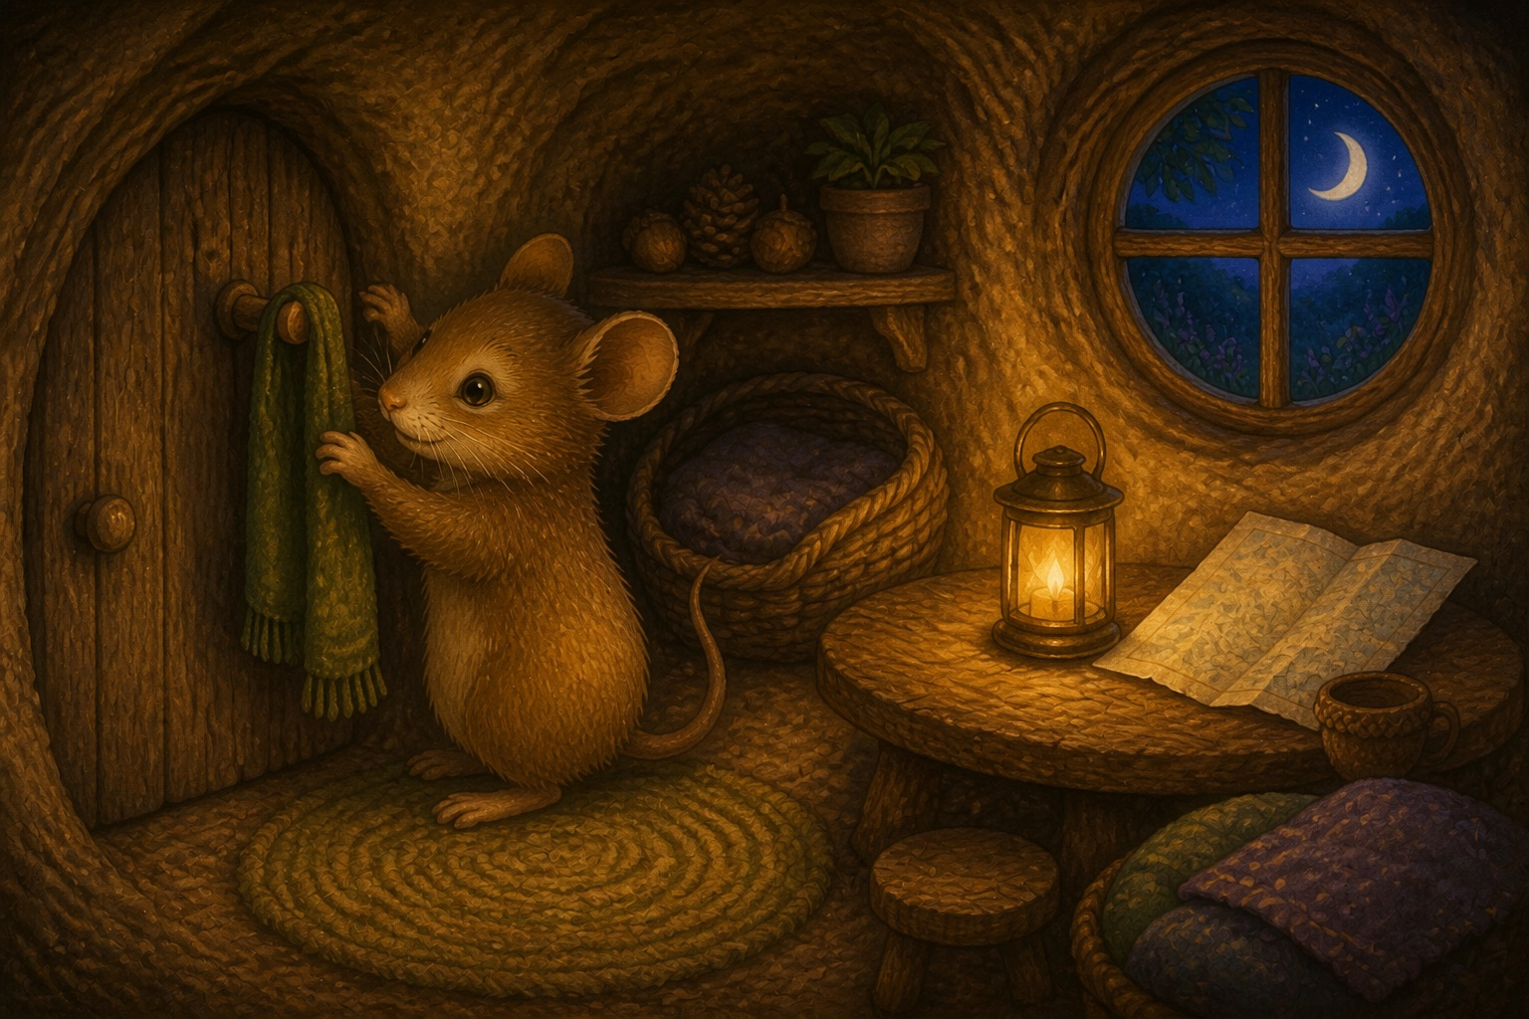
Milo followed the fireflies down the hill, across the silver creek, and past the oak with the deep roots.
Soon his round blue door stood in front of him.
Inside, Milo hung his green scarf on its peg. He placed the brass lantern on the table and unfolded the map one last time.
The golden circle was not treasure. It was the light from his own small window.
Milo smiled and folded the map along its soft, worn lines.
After that night, he still loved the paths he knew. But when a path was new, he no longer asked to see the whole way.
He looked for the next light.

